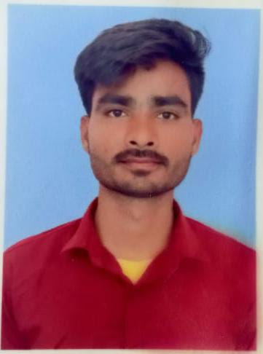RESUME

**NIKHIL**

Current add-Karan Market Near by Vardhman Hospital Muzaffarnagar 251001

Contact No. +91-8650166298

Email: [nikhilsainiwyd@gmail.com](mailto:nikhilsainiwyd@gmail.com)

**____________________________________________________**

**CARRIER OBJECTIVE:**

To enhance and utilize my technical knowledge and skills in an organization with considerable advancements opportunities.

**___________________________________­­­­_________________**

**PROFESSIONAL QUALIFICATION:**

BCA (Bachelor of Computer Applications) from Shri Ram College Muzaffarnagar (UP), Approved by Maa Shakumbhari University (MSU) Saharanpur , Uttar Pradesh.

**ACADEMIC QUALIFICATION:**

|  |  |  |  |
| --- | --- | --- | --- |
| **ACADEMIC QUALIFICATION** | **BOARD** | **YEAR** | **PERCENTAGE** |
| BCA (Bachelor of Computer Applications) | MSU | 2021-2024 | Processing |
| Intermediate | UPBOARD | 2021 | 72% |
| High School | UPBOARD | 2019 | 87% |

**SKILLS:**

* **C & C++ Programming Language**
* **Java Programming Language**
* **HTML & CSS**
* **MySQL**

**PROJECT:**

* **Minor project on Employee Information System. It is a software application.**
* **Front End : Java**
* **Back End : MySQL**
* **Amazon Clone using HTML & CSS**

**EXTRA CURRICULAR:**

* Participated in various activities like debate, extempore at school and college level.
* Participated in various sports at school and college level.

**STRENGTHS:**

* Positive Attitude
* Time Management
* Quick Leaner
* Self Confidence
* Hard Working

**HOBBIES:**

* To Explore New Things
* Listening to Music
* Watching News
* Reading Book

**PERSONAL DETAILS:**

**Father Name**: Mr. Ramdhan Singh

**Mother Name:** Mrs. Pushpa Devi

**DOB: 11/05/2004**

**Gender:** Male

**Marital Status:** Unmarried

**Languages:** Hindi & English

**Nationality**: Indian

**Permanent Address: Vill-Khaikhera, Jansath Muzaffarnagar Pin Code-251314 (UP)**

**DECLARATION:**

**I hereby declare that the above mentioned details are true and correct to the best of my knowledge**

**Date:**

**Place: (**Nikhil**)**